Instructions for Joining and Participating in EGATIN’S VIDEO CONFERENCE MEETINGS and GROUPS

If you have registered for the video conference you will receive the links to the presentation, and all the meetings, and groups which you are entitled to attend.
JOINING A ZOOM MEETING
- In order to join the various meetings and groups during EGATIN’s video conference by a) computer, tablet, or smartphone, or by b) phone only, follow the steps below:

- To join the Zoom meeting by computer, tablet, or smartphone, you will need to download the Zoom app well before joining a meeting for the first time. A separate invitation to each Zoom meeting (presentation, meetings, and groups) containing a link to that meeting, the meeting ID and password and will be sent to your email address and then either:

- Click on the link to the meeting or
- If you have Zoom open and click on “Join a Meeting” you will see the box below. Enter the 10-digit code contained within the invitation into the box which says: “Meeting ID”
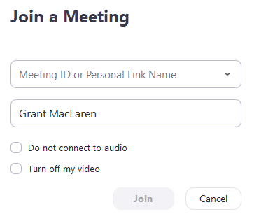
Select if you would like to connect audio and/or video and click Join.
- by phone only (no video) you don’t need to download the app and I will text you the number to call to dial in to the meeting and the 10-digit “Meeting ID” you will be asked to provide;
- Zoom displays the names of participants alongside their photo. It is helpful if you have your full name visible and you can change this by clicking on the three dots in the top right corner of the individual image you share onscreen with others.
- When you join the presentation, meeting, and/or group you will first be held in a “waiting room” from where you will be admitted in time for the start of the event.

GUIDELINES FOR ONLINE GROUPS
Zoom is a recommended platform for online groups as it’s considered to be conscientious in offering a confidential and reliable service.
When meeting online there are arrangements participants can make to ensure that the boundaries and confidentiality can be protected. These include:
- Arranging to be in a quiet and private room for the duration of the group. This may mean making your family and friends aware that this is a confidential meeting which should not be interrupted.

- Ensuring that there are no other interruptions e.g. phone calls, emails, texting etc, by turning off your other devices as you normally would when joining a meeting or group session.

- To preserve the confidentiality of the group, the recording facility has been disabled and you are asked not to use the chat function.

- We also recommend you use headphones or earphones when in the groups as this contributes to the confidentiality and can enhance sound quality and/or hearing.

- Ideally joining the online group from the same place for each session. This will be helpful both for you and for other group members although this may not always be possible.

- Treating these online sessions with the same seriousness as a face to face meeting or group sessions by not bringing food, tea and coffee, alcohol, or pets, etc, into the sessions.

- In order to reduce the background noise, it would be helpful to mute your microphone in moments that you are not talking.

General Issues
You can participate in a Zoom group without setting up a Zoom account but it may be helpful if you do so – this is free.
Collaborative expertise:
This is a new experience for us all and a steep learning curve. Some of you will be much more confident and proficient in working in this way, so if you have any suggestions or comments that would optimise the experience, it would be very helpful to share them.
There are bound to be some initial problems but there is sufficient evidence to show that online groups can work well and that these can be overcome.
EGATIN - October 2020

